Install and use Open VPN.
- Download Open VPN from website:
https://openvpn.net/index.php/open-source/downloads.html
Select the version of windows (Installer (64-bit), Windows Vista and later or Installer (32-bit), Windows Vista and later for windows 7 or windows 8).
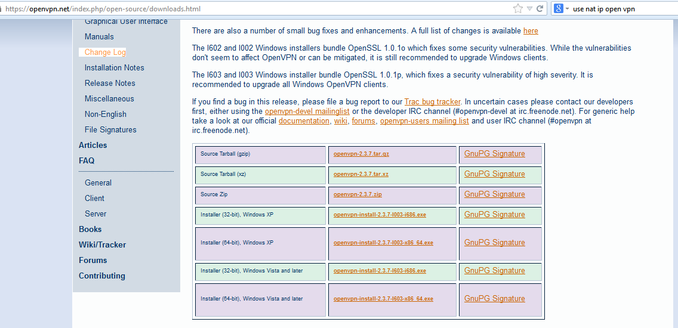
- After download, install the software.
- Dowload file bitel_partner.ovpn file (we will send), then paste to the folder:
C:\Program Files\OpenVPN\config

- Run Application by right click to the icon, select Run as Administrator.
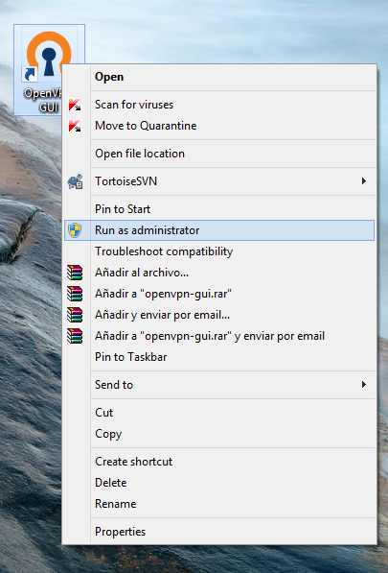
- After start application, one icon appears on the taskbar (often in the right corner of screen), right click to it and select Connect.
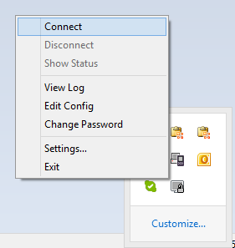
- One screen appears; enter username and password to login.
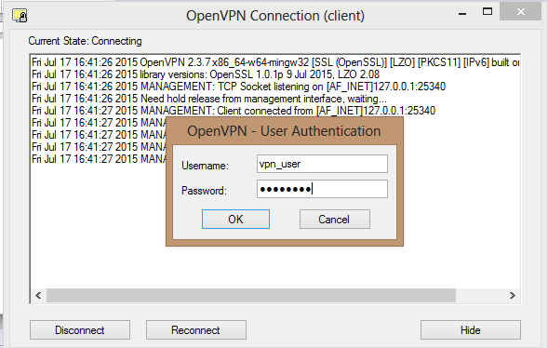

- After login successfully, the icon will change to green, try to connect to the system.

